Write blocker

This application is designed to block all the external storage devices that are plugged into computer as READ-ONLY device and provide the GUI for user to unblock the devices by applying different mode (READ-ONLY or READ-WRITE) . The application also keeps log of application and system errors, as well as the user activities to the application.

The application has three parts. The first part is UDEV rules script which blocking all the devices at the early stage of mounting process. The second part is device indicator, which will detect any connected devices with brief info. The third part is the GUI application, it lists the devices with all information and functions to change the status of any selected devices, as well as the ability to view logs.

The things left to be fixed and done:

Issues:

1. The height of Write-blocker window can be resized to below 0 , getting GTK-WARNING when the window is resized to minimum

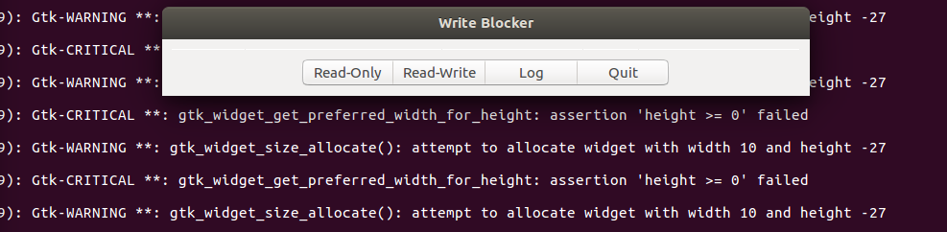

Need to set the height of window can’t be less than 0

1. When the status of a drive is changed, treeview will update itself simultaneously. However, the status of the drive stays the same on device indicator. The status of changed device should be updated on device indicator as well

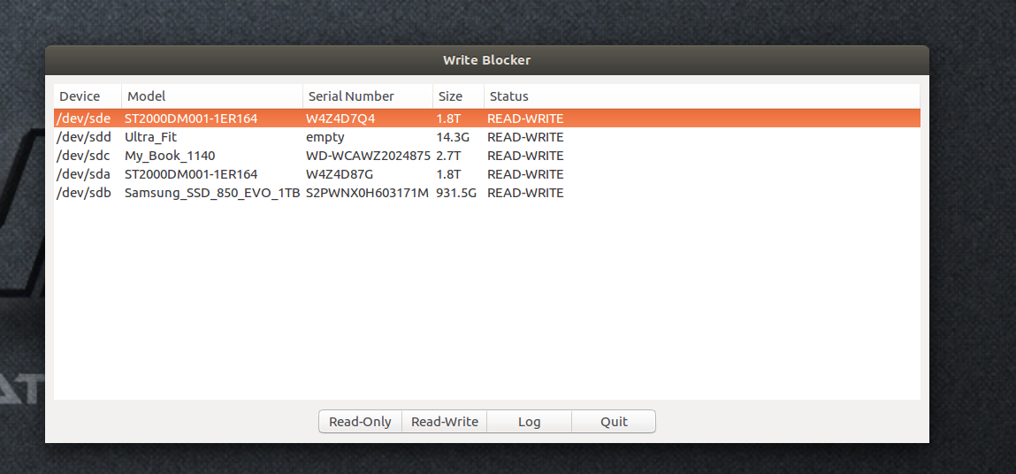

Things need to be added:

1. Colour code

If the drive is READ-WRITE , it shows as GREEN , otherwise RED

Note : just need to colour code the font not the whole grid , the screenshot below just to show which part needs to be colour coded .

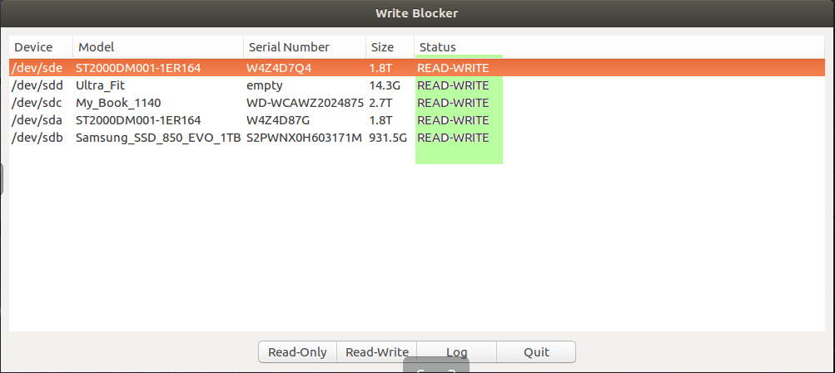

1. Application icon

Add an application icon next to the window header like the screenshot shown below

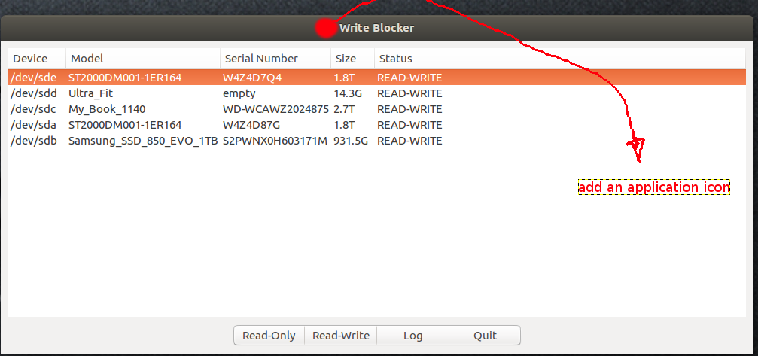

1. create a separated GUI for logs

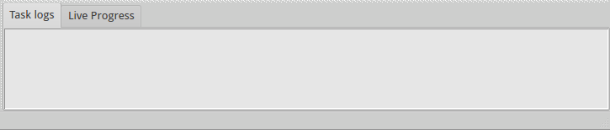

A window with two tabs , Task logs and System logs all these logs will be saved and zipped automatically when the write blocker application is terminated ( using logrotate command to zip the files and save them to /var/log/WB_logs folder with date as file names, so logs within Task logs needs to be saved as **09-08-2017-Task** and system logs will be save as **09-08-2017-Sys**. these logs will be kept forever unless manually delete them .

The things we would like to log and formats are below:

For Task logs tab

1. date and time (this has to be UTC date and time )
2. the username who initialised the application
3. device details and any changes that user is made to devices
4. Terminate application when user close the window

Example:

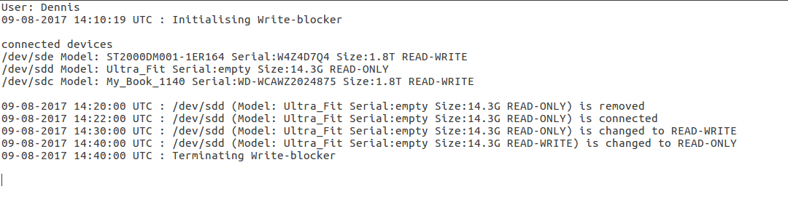

For System logs tab

All the system errors that relates to the application will go to this tab

1. Date and time (UTC again )
2. Error messages

This one is sample it doesn’t have to be in a particular format as long as it’s easy to read

The design of the message window needs to be black background with green text fonts like the example below .

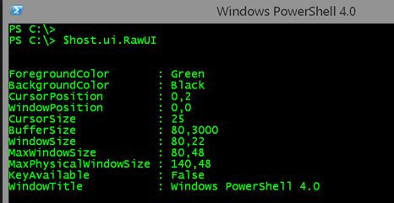

Once this done link the log GUI to the Log button on Write-blocker GUI .

Finally link Write-blocker application to the **Open Write Blocker** button on wb_indicator menu. So when user click on that button on indicator menu it opens up Write Blocker Application. However , it has to be run as gksudo and user will need to enter the password to run it as root so the device info will be retrieved properly .